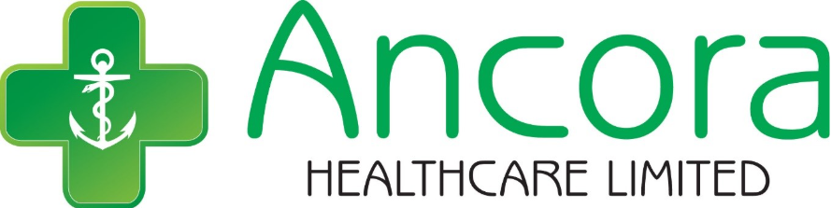

How to Complain or Compliment

How to Complain or Compliment

Opening Hours:

Monday to Friday: 9am to 11.30pm

Saturday 5pm to 11.30pm

Sunday: 10am to 12am

Telephone: 01724 877100

Email: pharmacy.ff058@nhs.net

When we are closed
If you need medical help when the pharmacy is closed:
- Visit NHS 111 online at www.111.nhs.uk
- Call 111 for urgent medical advice
For serious or life-threatening emergencies, call 999 or go to your nearest Accident & Emergency (A&E) department.
You can also find other open pharmacies by searching online for
“NHS find a pharmacy near you”.

Grace Bollington MPharm, PgDip Clin Pharm, MRPharmS, IP

This Pharmacy is owned by:

Ancora Healthcare Limited

291 Ashby Road

Scunthorpe

DN16 2AB



Pharmacy staff aim to give the best possible care to patients but sometimes things go wrong. The NHS Complaints Procedure was set up to use if you want to complain about the services or treatment you get from the NHS.

Alternatively, you may wish to get in touch with the providers of your NHS treatment in order to send a goodwill message or to offer thanks.

If you are unhappy with the treatment or service that you have received from the NHS you are entitled to make a complaint, have it considered, and receive a response from the NHS organisation concerned.

A complaint can be made by a patient or person affected or likely to be affected by the actions or decisions of an NHS organisation. A complaint can also be made by someone acting on behalf of the patient or person, with their consent.

You should normally complain within 12 months of the event(s) concerned or within 12 months of becoming aware that you have something to complain about. Complaints managers in NHS organisations have discretion to waive this time limit if there are good reasons why you could not complain earlier.

The first stage of the NHS complaints procedure is ‘Local Resolution’. Local resolution aims to deal with and resolve complaints quickly and as close to the source of the complaint as possible using the most appropriate means.

You can raise your concerns immediately by speaking to a member of staff. They may be able to resolve your concerns without the need to make a formal complaint.

If you do want to continue with your complaint you can do this orally or in writing (including email) to the NHS organisation or pharmacist concerned.

The designated ‘Responsible Person’ and Complaints Manager for Ancora Healthcare Limited is:
Grace Bollington
Superintendent Pharmacist
Ancora Healthcare Limited
291 Ashby Road
Scunthorpe
DN16 2AB
Tel: 01724 877100
Email: pharmacy.ff058@nhs.net

What Happens Next
If you make a complaint, you can expect:
- An acknowledgement within 3 working days
- Regular updates throughout the process
- A full written response, usually within 25 working days (and up to 6 months if required)
If you make a verbal complaint, a written record will be created.

Escalation to NHS England
Alternatively, you may choose to address the complaint directly to NHS England:
Email: england.contactus@nhs.net (Please state “For the attention of the complaints team”)
Telephone: 0300 311 22 33
Post:
NHS England
PO Box 16738
Redditch
B97 9PT

Independent Support
NHS Complaints Advocacy Wakefield
Units 3, 4 & 5
The Gaslight, Lower Warrengate
Wakefield
West Yorkshire
WF1 1SA
Telephone: 0300 330 5454

Document Control
Responsible Person for Complaints: Ms Grace Bollington
Superintendent Pharmacist
Ancora Healthcare Limited
Review Date: 21/04/2027

